Use-Case Realization Report (Analysis)
Delete MCQ

Issue 1.0
Revision History
Date | Issue | Description | Author
01/Aug/09 | 1.0 | First Issue | Thomas Yap

Table of Contents
1. Brief Description 4
2. Flow of Events 4
2.1 Standard Flow 4
2.1.1 Delete MCQ 4
2.2 Exception 4
3. Interaction Diagrams 5
3.1 Collaboration Diagram for Delete MCQ 5
4. Participating Objects 5
5. Class Diagrams 6
5.1 Class Diagram for Delete MCQ 6
6. Derived Requirements 6

Use-Case Realization Report
Delete MCQ

Brief Description
This use case enables the controller to delete multiples choice question profile with its properties and parameters. It involves displaying the menu and form and search by searchstrings or list to remove the data.

Flow of Events
The standard flow of events for this use case and any exceptions are described in the following subsections. The events are described in terms of Actors and Analysis Objects.

Standard Flow
This use case covers the MCQ Maintenance - Delete MCQ. The standard flow of these events are described below.

Delete MCQ
The running of the application is shown in section 3.1. The flow of event is as follow:

- When the application start, the first operation to be performed is the startup operation of the main controller. This operation will create all the control objects and the entity objects necessary for operation Delete MCQ:
  - The control object created is: MCQ Controller
  - The entity objects create are: MCQ Table and Transaction Record

- The main controller will start the main function menu:
  - To start Delete MCQ, operation FormDisplayMCQ is activated by MCQ Controller to display a MCQ form.
  - Portal Admin will select the MCQ to be deleted. This is done by activating Use Case Display MCQ Info or Display MCQ List. Use Case Display MCQ List will retrieve a title list of MCQ for Portal Admin to pick to be display on FormDisplayMCQ.
  - Then MCQ Controller will check for additional criteria if any.
  - If no record found, MCQ Controller will send a error message to FormDisplayMCQ Interface.
  - After the record is found and display on FormDisplayMCQ, a confirmation request will be sent to the FormDisplayMCQ interface. Upon confirmation, the record will then be flagged as deleted using operation delete to entity object MCQ Table.
  - In addition, a transaction log will be created by operation createRecord and store in entity TransactionRecord.
  - A confirmation message will be displayed by FormDisplayMCQ interface.

- Step 2 will be repeated until all deletions are completion. Then controller will terminate the application by issuing operation close.

Exception
None.

Interaction Diagrams

Collaboration Diagram for Delete MCQ
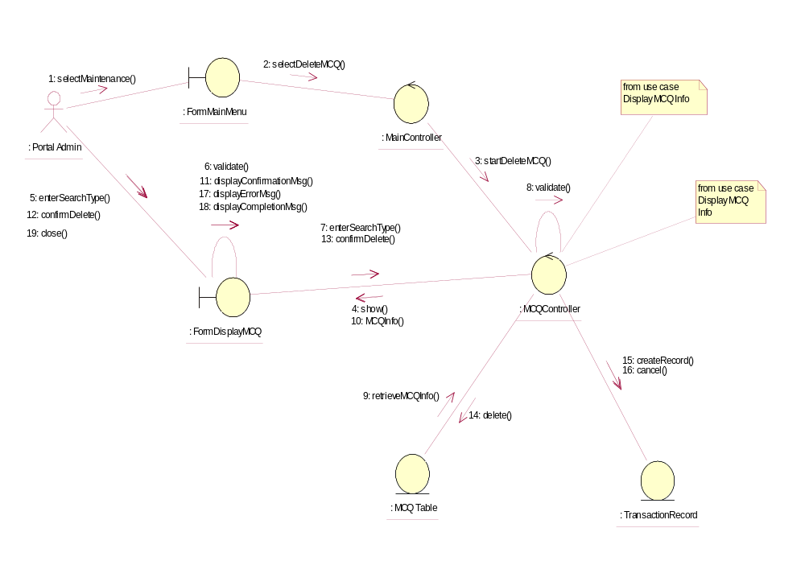

Participating Objects
: FormDisplayMCQ
This object is the interface for displaying MCQ details search activities.

: FormMainMenu
This is the main menu at the beginning of the application from where it can access the MCQ Maintenance - Delete MCQ operation.

: MainController
This is the main controller that control the whole system.

: MCQ Table
This table stores all the properties and parameters of exam or exercise questions.

: MCQController
This is the controller for MCQ Maintenance. It creates and activates FormDisplayMCQ interface and MCQ Table.

: Portal Admin
This is the only actor that authorized to perform operation MCQ Maintenance - Delete MCQ.

: TransactionRecord
This is the entity object that created for transaction log and audit trail.

Class Diagrams

Class Diagram for Delete MCQ
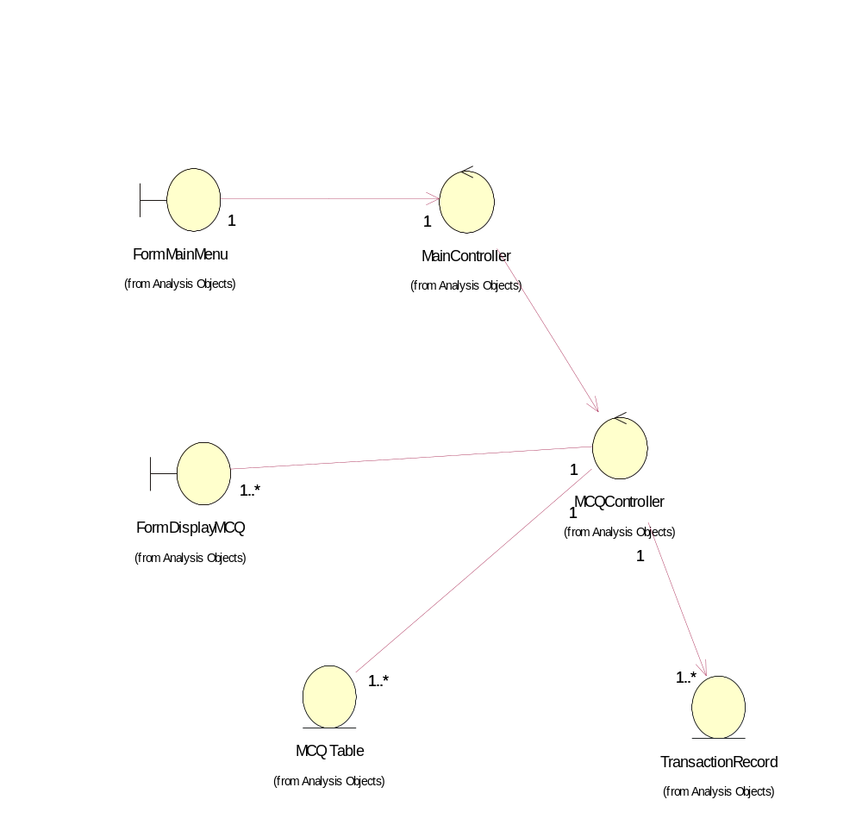

Derived Requirements
The FormMainMenu and FormDisplayMCQ Interface should have the format specified in User Requirements Specification for Content Management Portal.

